**RSA Public-Key Encryption and Signature Lab**

**Karan Amrutesh**

**Task 1: Deriving the Private Key:**

* Code:

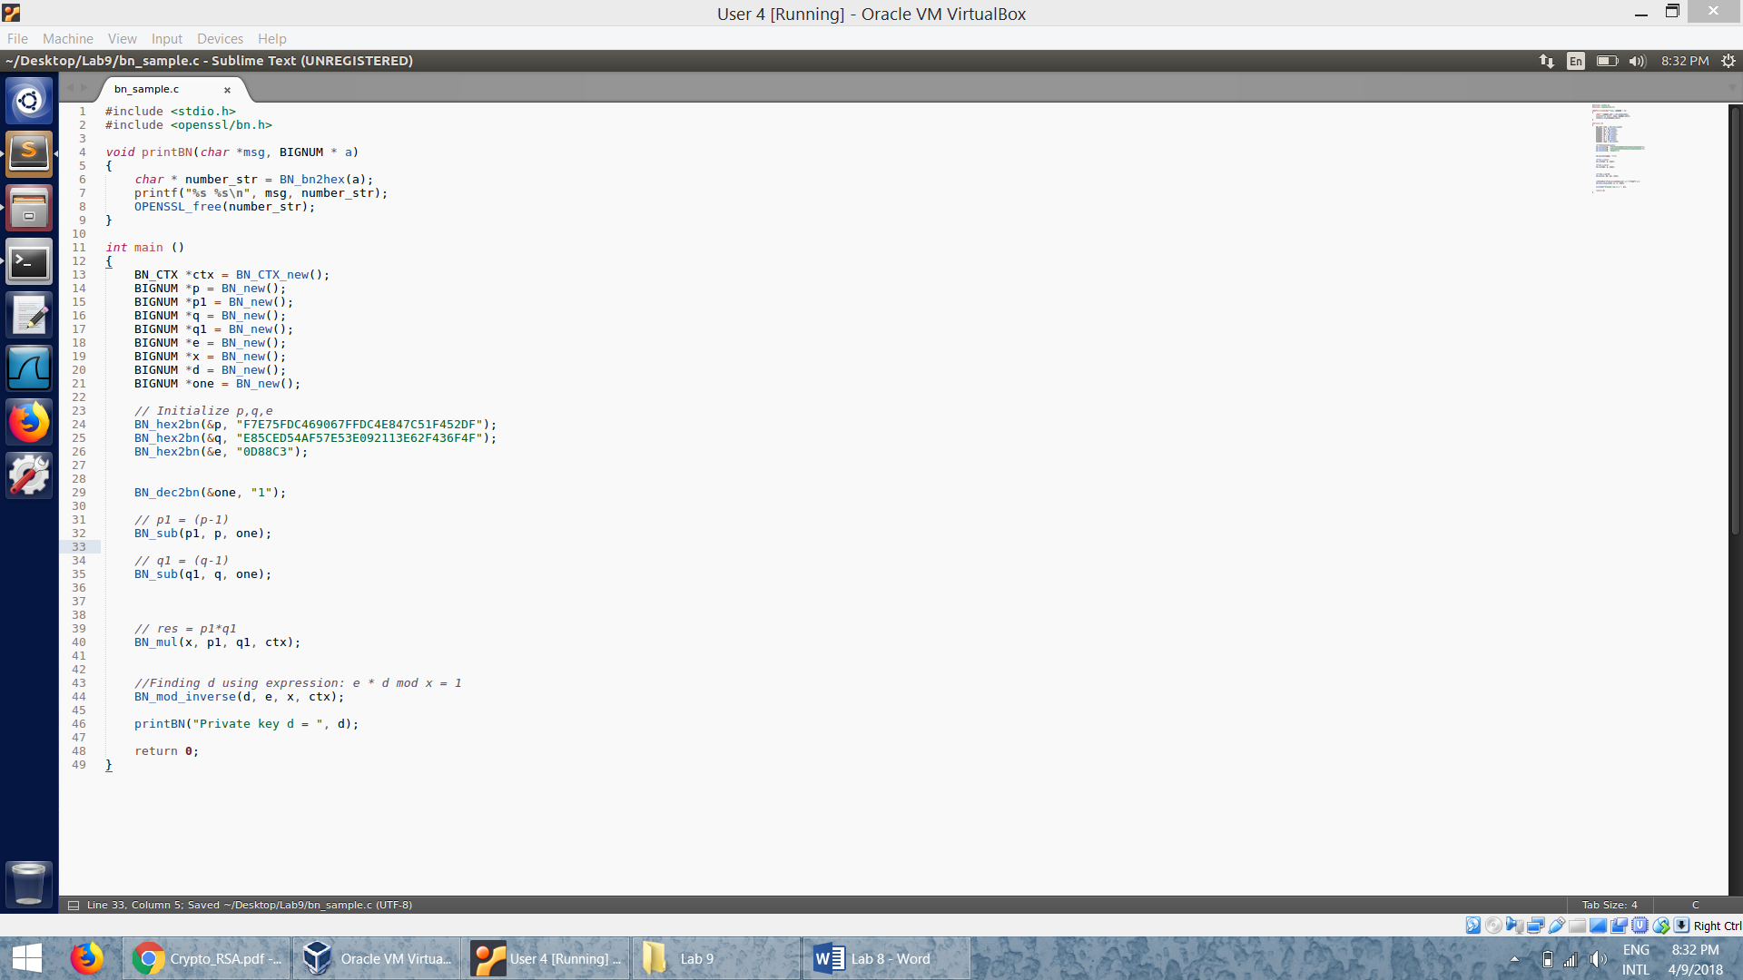

* Given the values of *p,q and e*  we caclucalte the value of private key, *d.*
* Note that we have to convert all the parameters used into bignum.
* We execute the code:

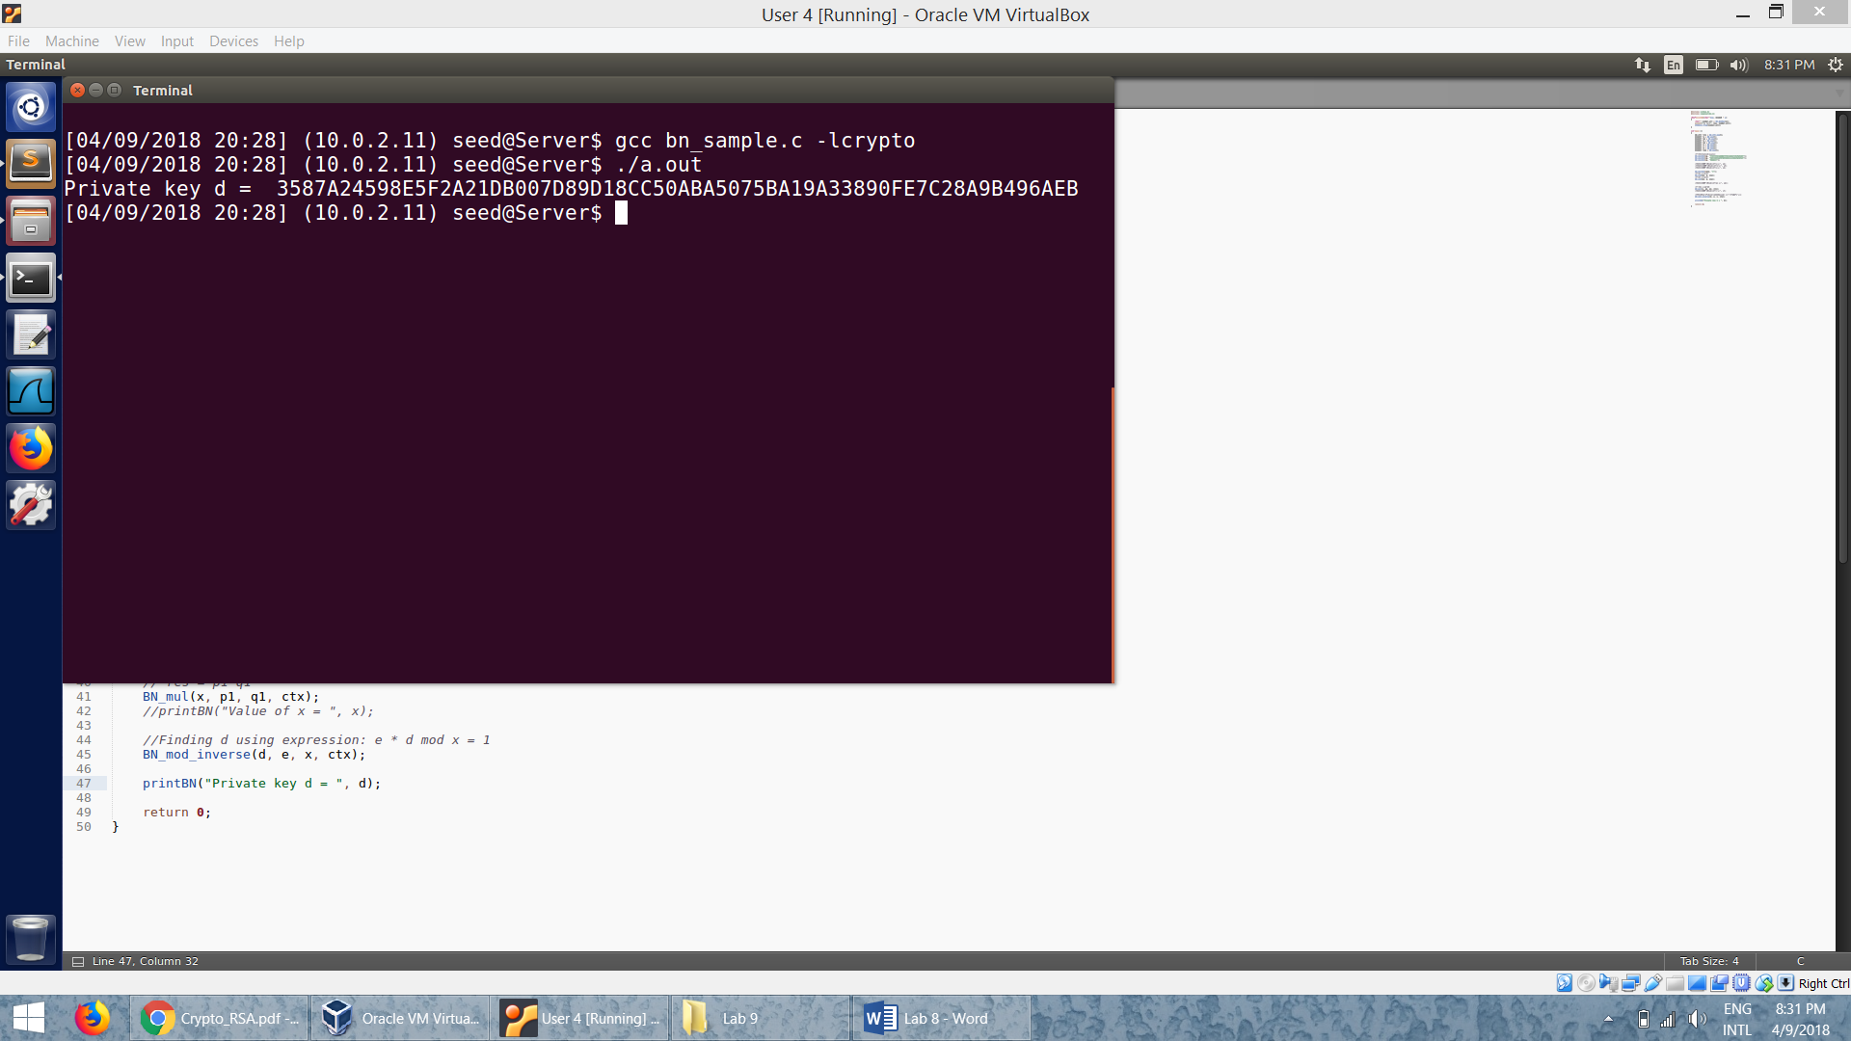

**Task 2: Encrypting a Message**

* Code:

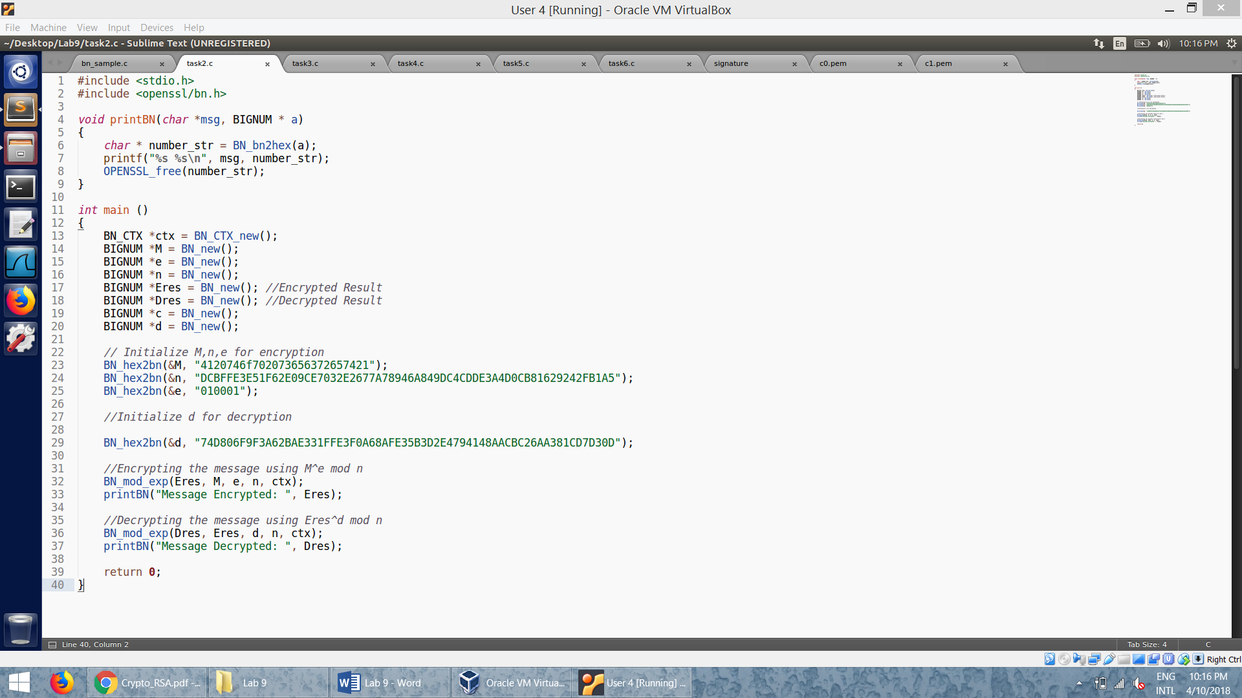

* We get the hex value of the message “A top secret!” using python.
* Using the vallues of *M,n* and *e,* we encrypt the message, M by using the formula *M^e mod n.*
* Then we use the encrypted resultand *d*  to decrypt the message:

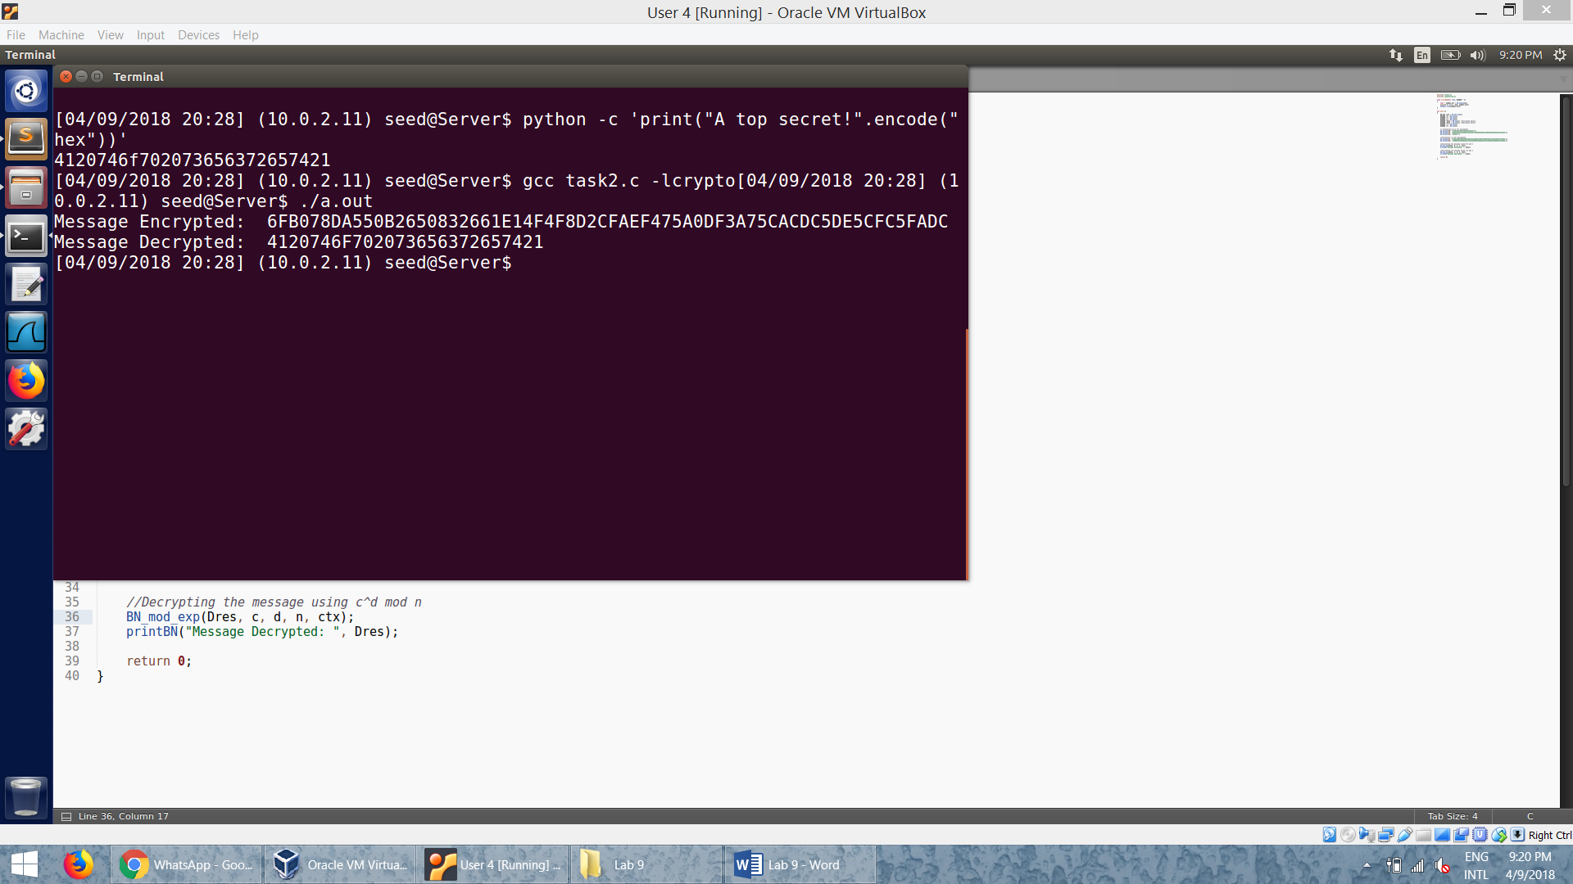

* We can see that the decrypted message and the original message are the same.

**Task 3: Decrypting a Message**

* Code:

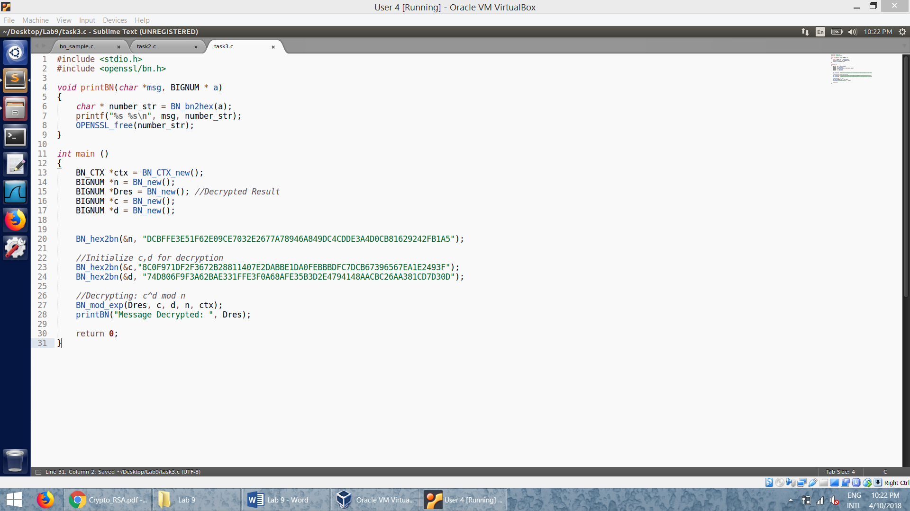

* We decrypt the given cipher text, *c* using the formula: *c^d mod n.*
* By decrypting, we get the hex value of the message.
* We then use the python to decode the hex value:

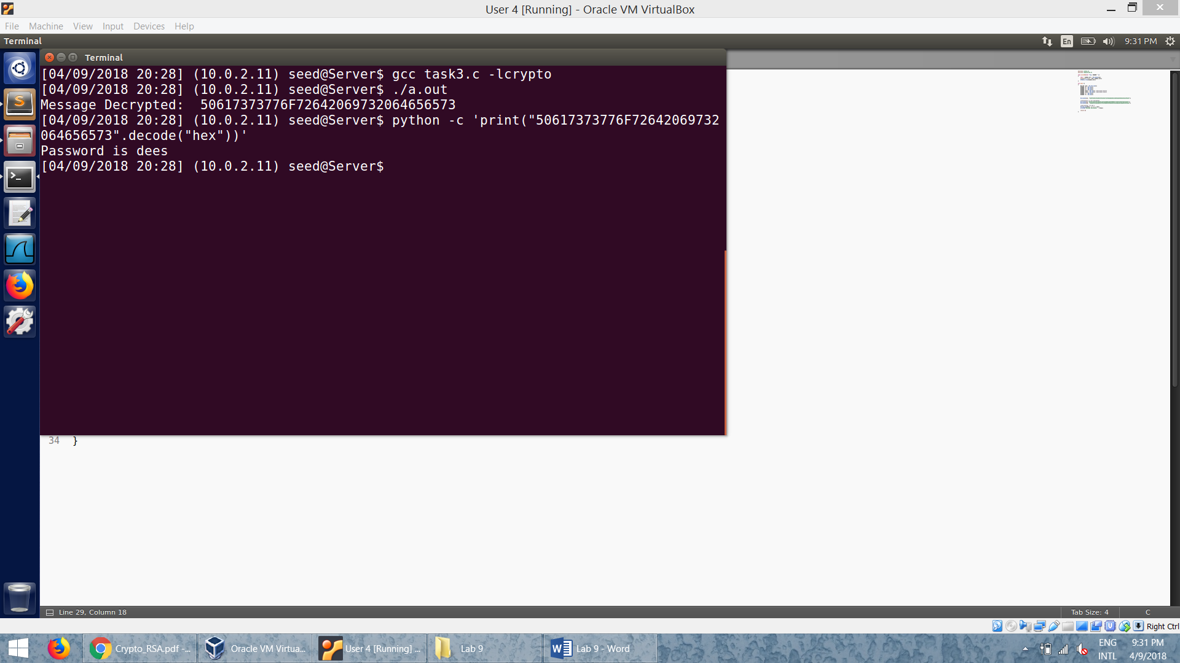

**Task 4: Signing a Message**

* Code:

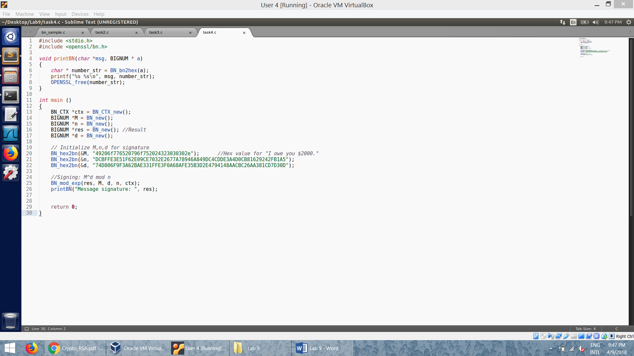

* We get the hex value of the message “I owe you $2000.” using python.
* We run our code to produce the signature for the message:

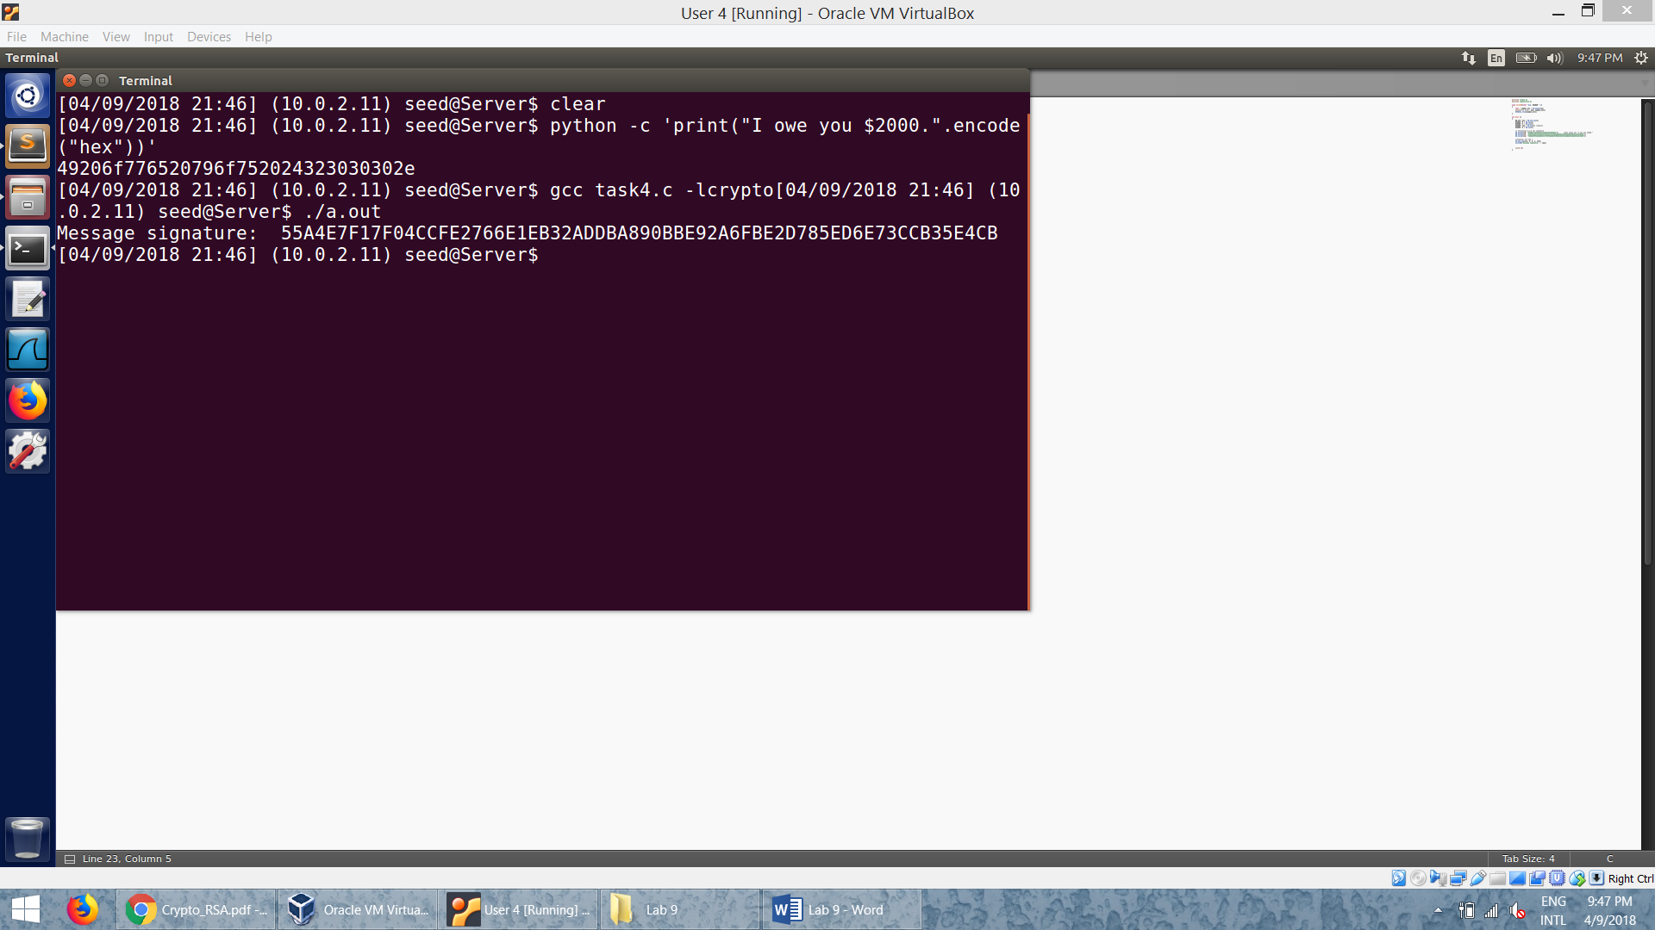

* We get the hex value of the message “I owe you $3000.” using python.
* We run our code to produce the signature for the message:

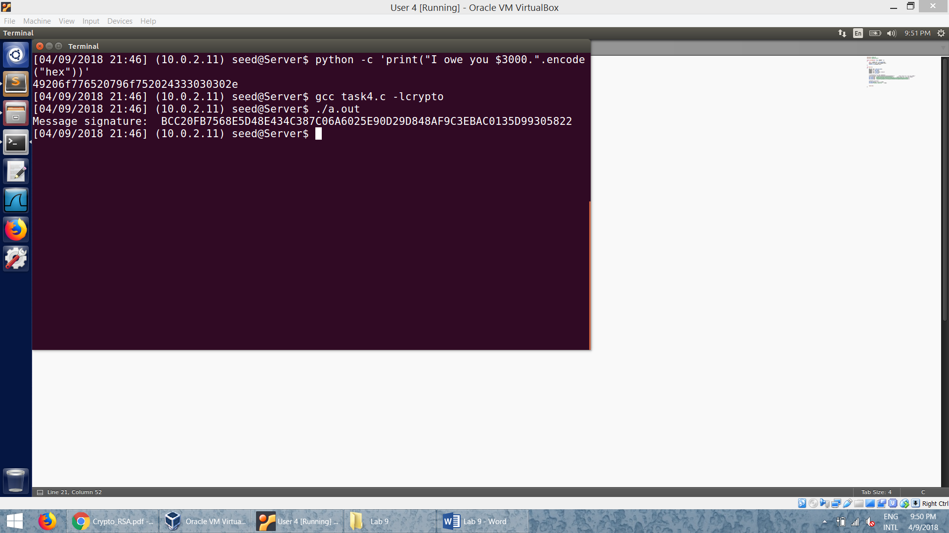

* We can observe that, though there is only one byte of difference in the message, their signatures differ completely.

**Task 5: Verifying a Signature**

* Code:

.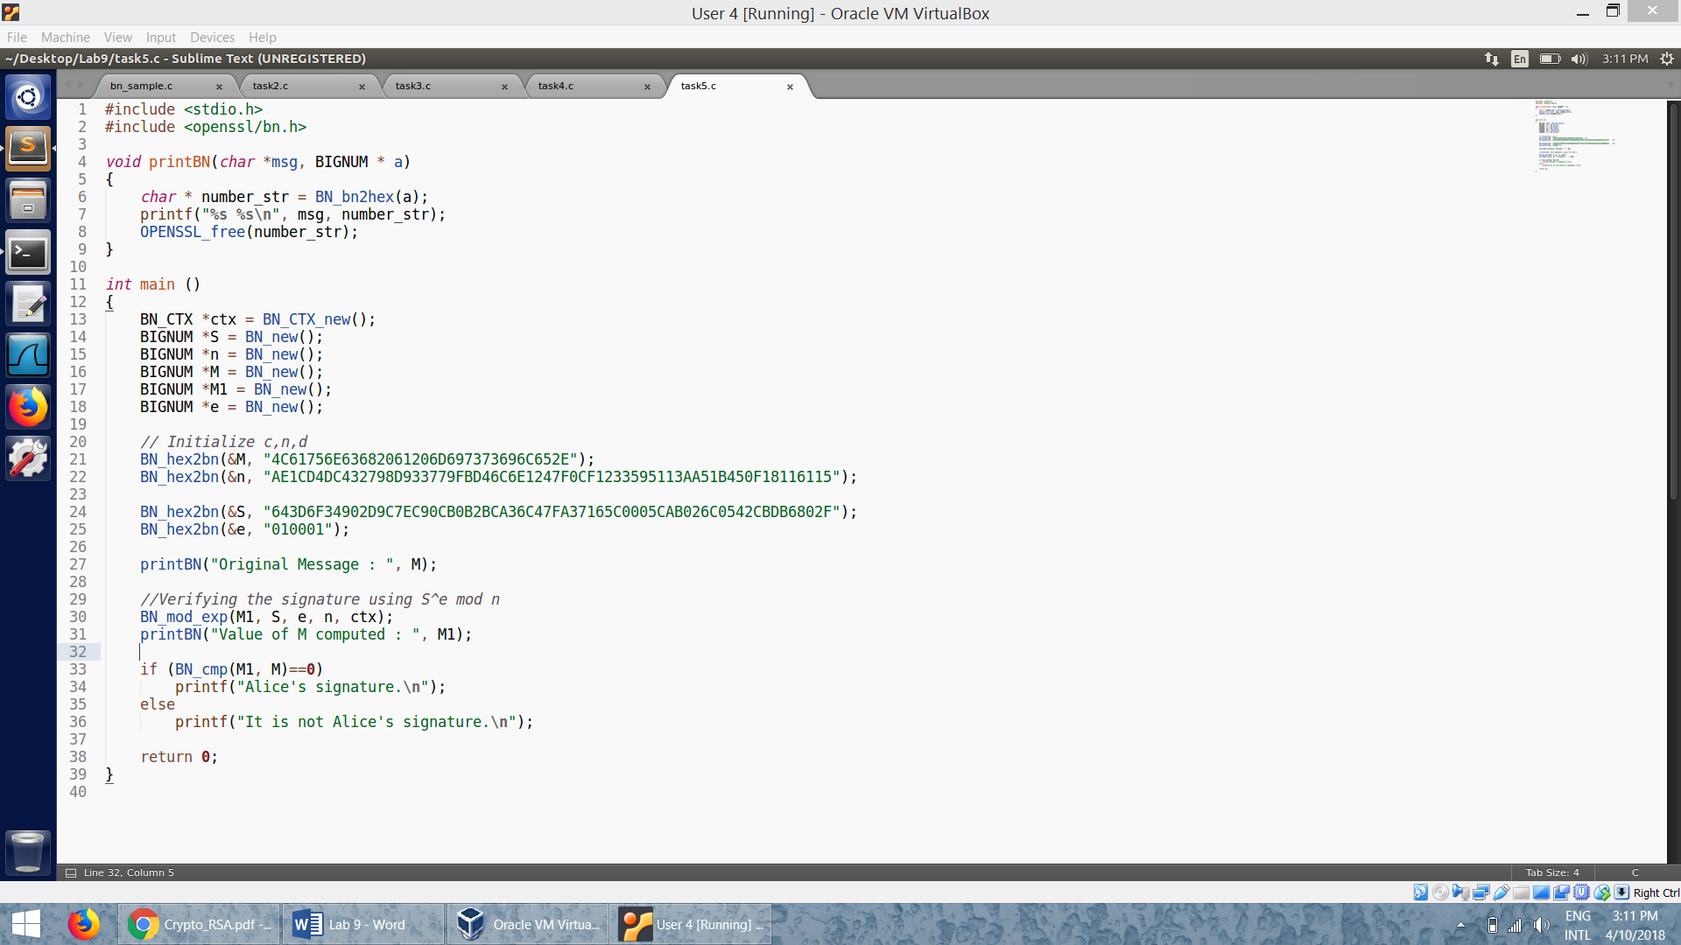

* We get the hex value of the message M, “Launch a missile.” using python.
* We use the signature to compute the value of the message M1.
* We then use the BN_cmp API in order to compare the two messages and conclude whether the signature is Alice’s or not:

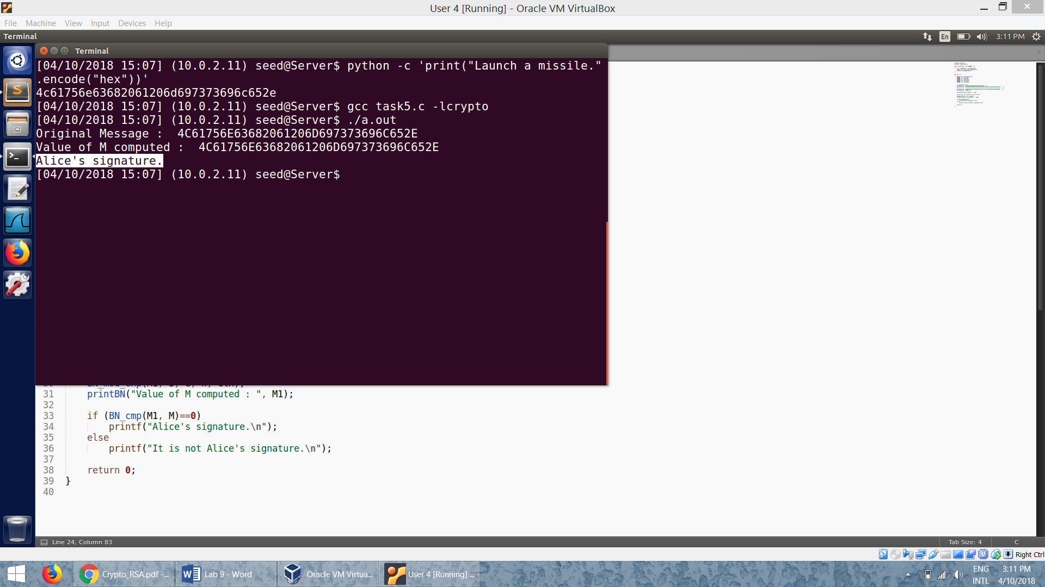

* We make change to the signature (from 2F to 3F):

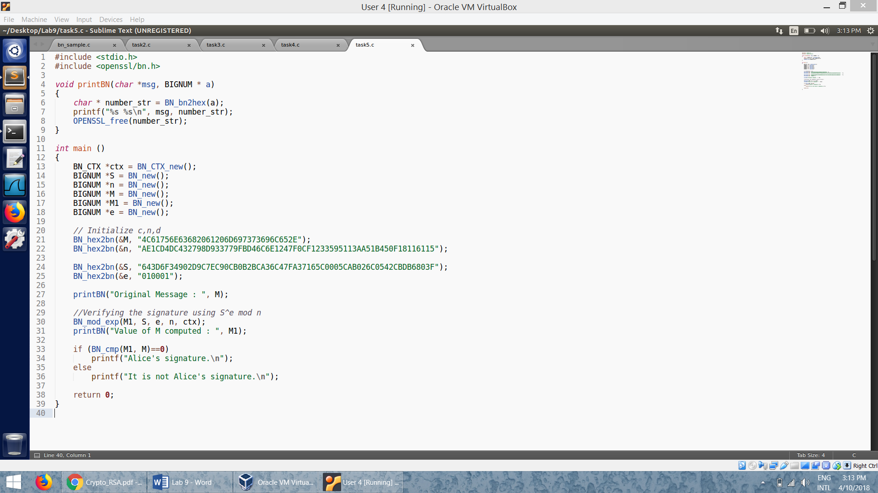

* We use the signature to compute the value of the message M1.
* We then use the BN_cmp API in order to compare the two messages and conclude whether the signature is Alice’s or not:

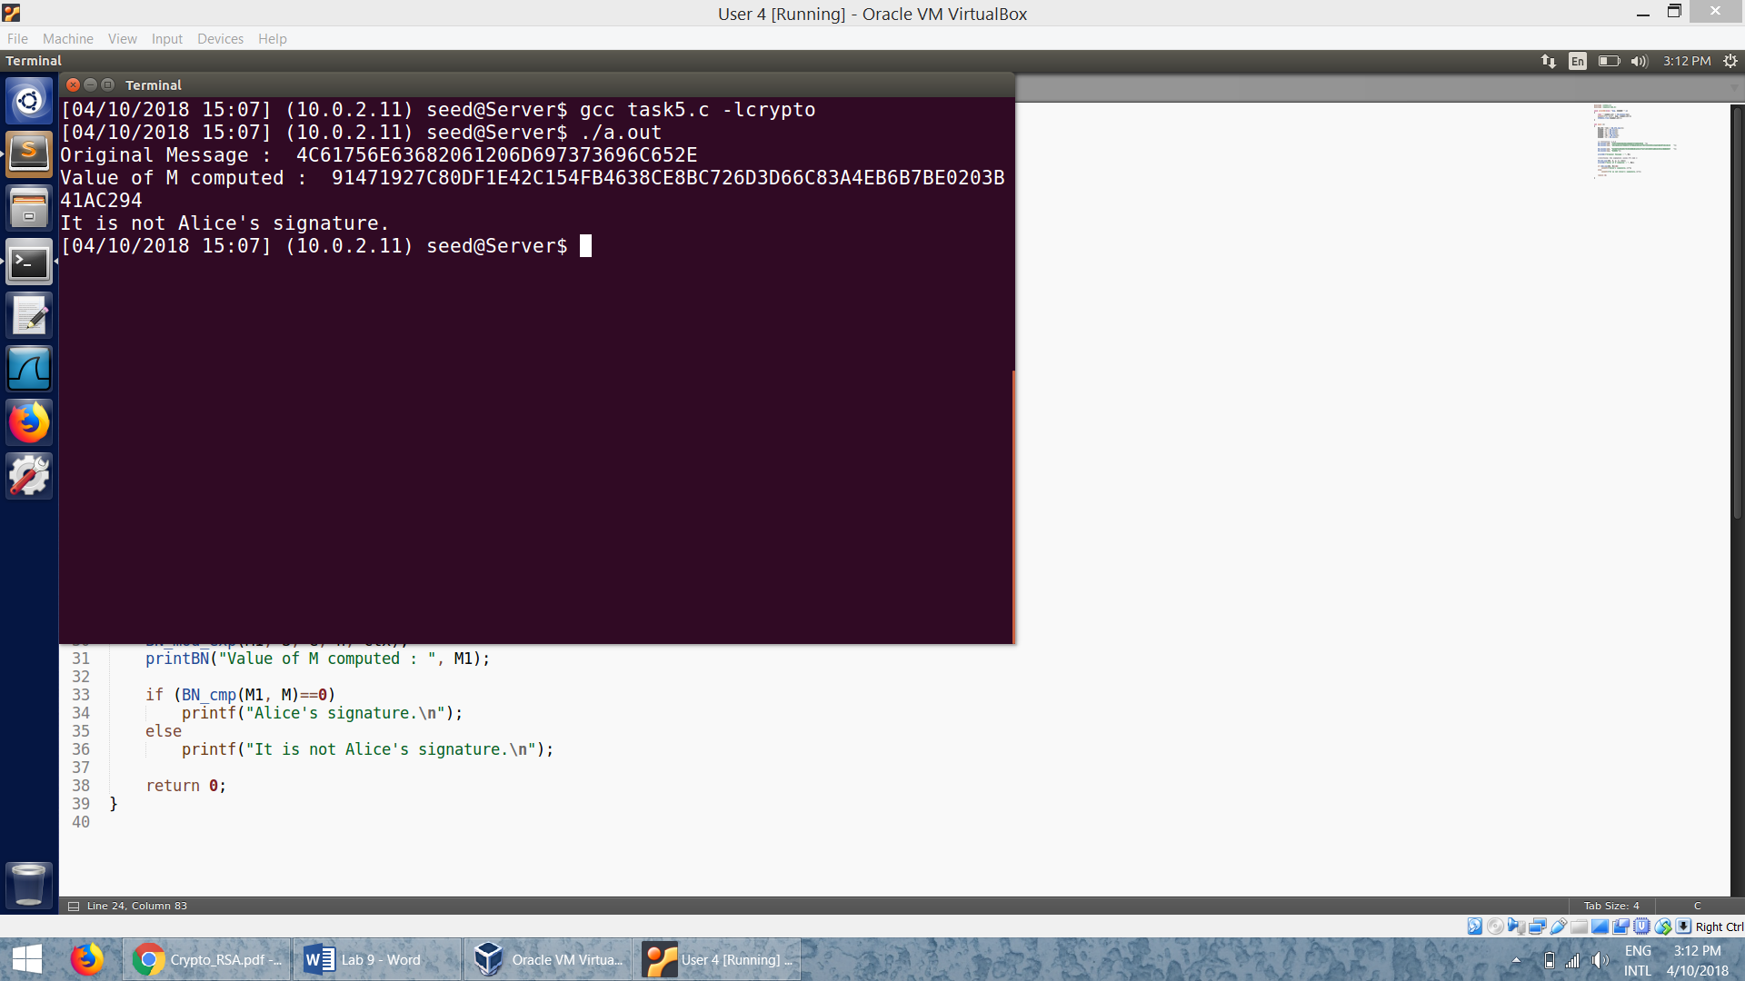

* We can see that the message produced using the changed signature is entirely different even though only 1 byte of the signature is changed.

**Task 6: Manually Verifying an X.509 Certificate**

**Step 1: Download a certificate from a real web server.**

* We download the certificate of www.googl.ecom:

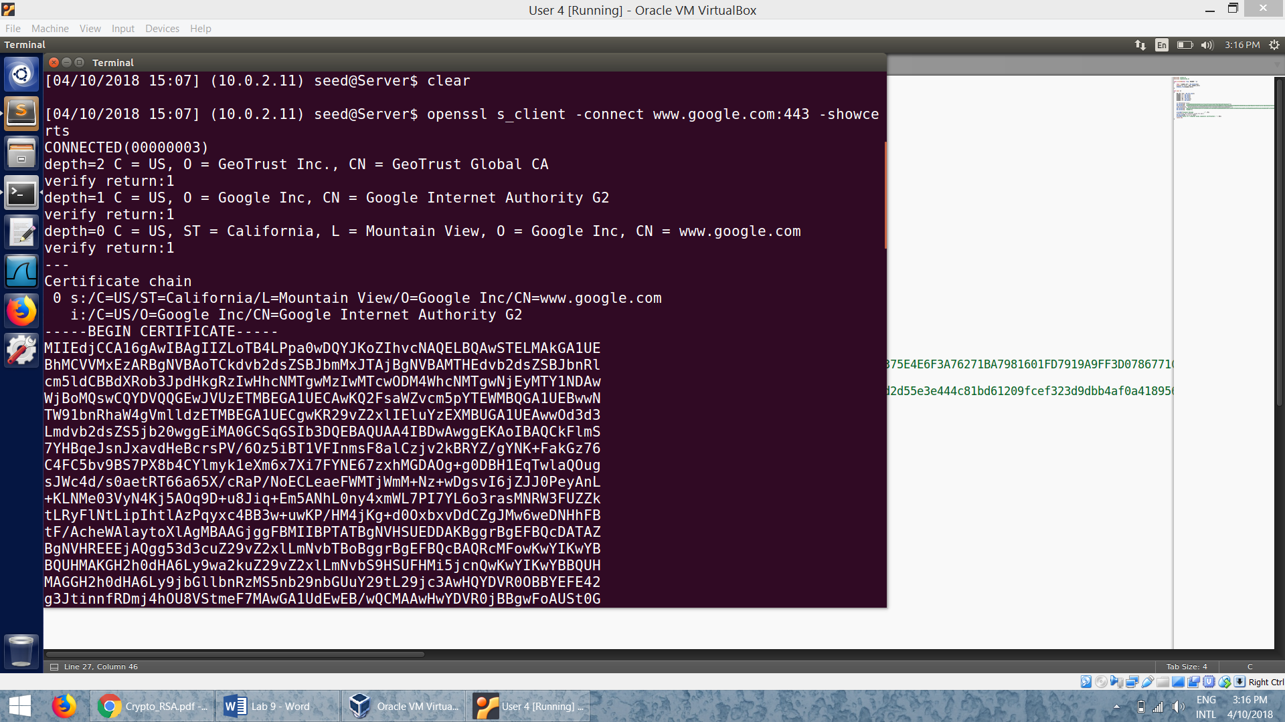

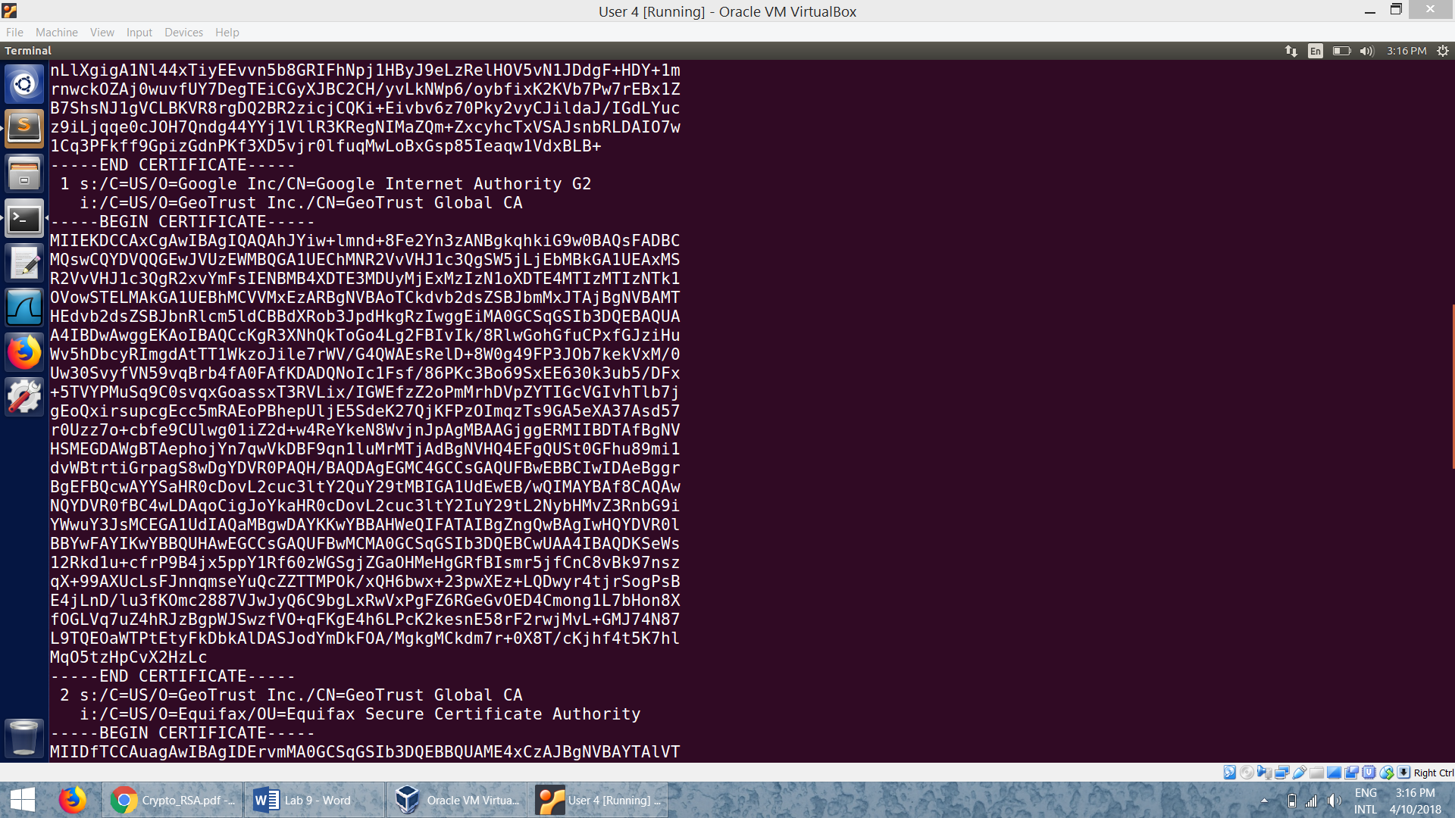

* We save these two certificates in the files *c0.pem* and *c1.pem* respectively.

**Step 2: Extract the public key (e, n) from the issuer’s certificate.**

* We get the value of *n* using –*modulus*:

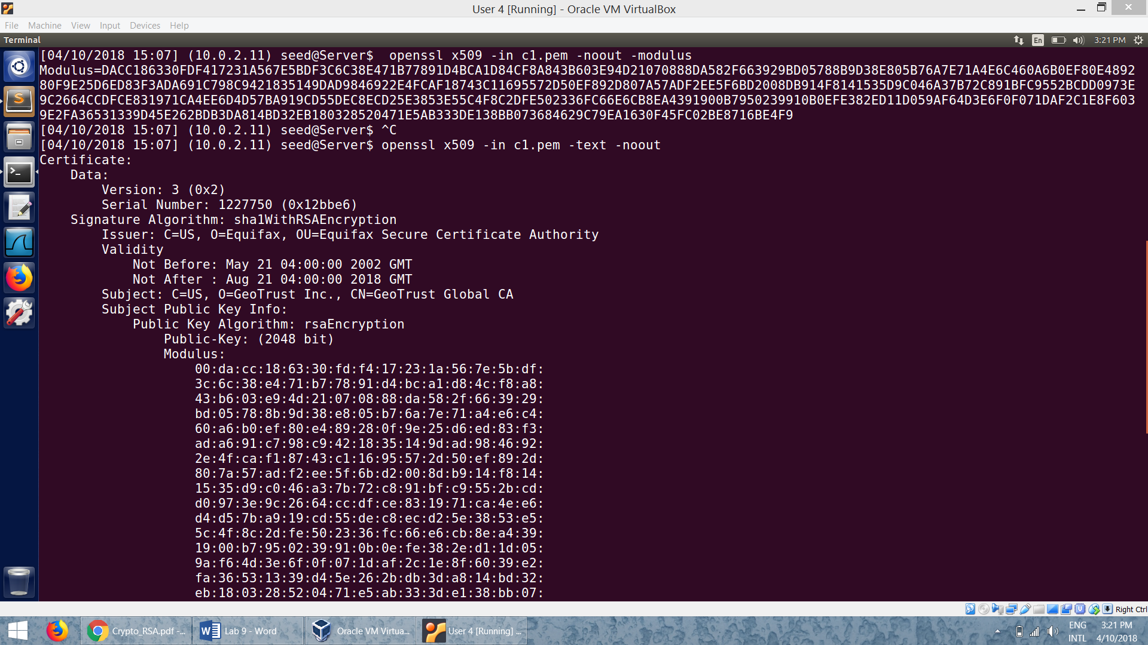

* We find the *exponent, e:*

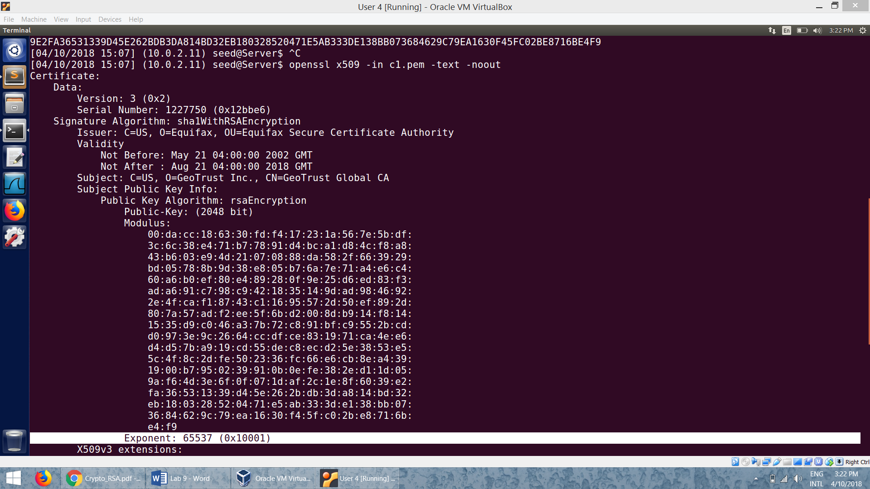

**Step 3: Extract the signature from the server’s certificate:**

* We run the command: *openssl x509 -in c0.pem -text –noout* to extract the signature from the server’s certificate, *c0.pem.* We put this signature into a file.

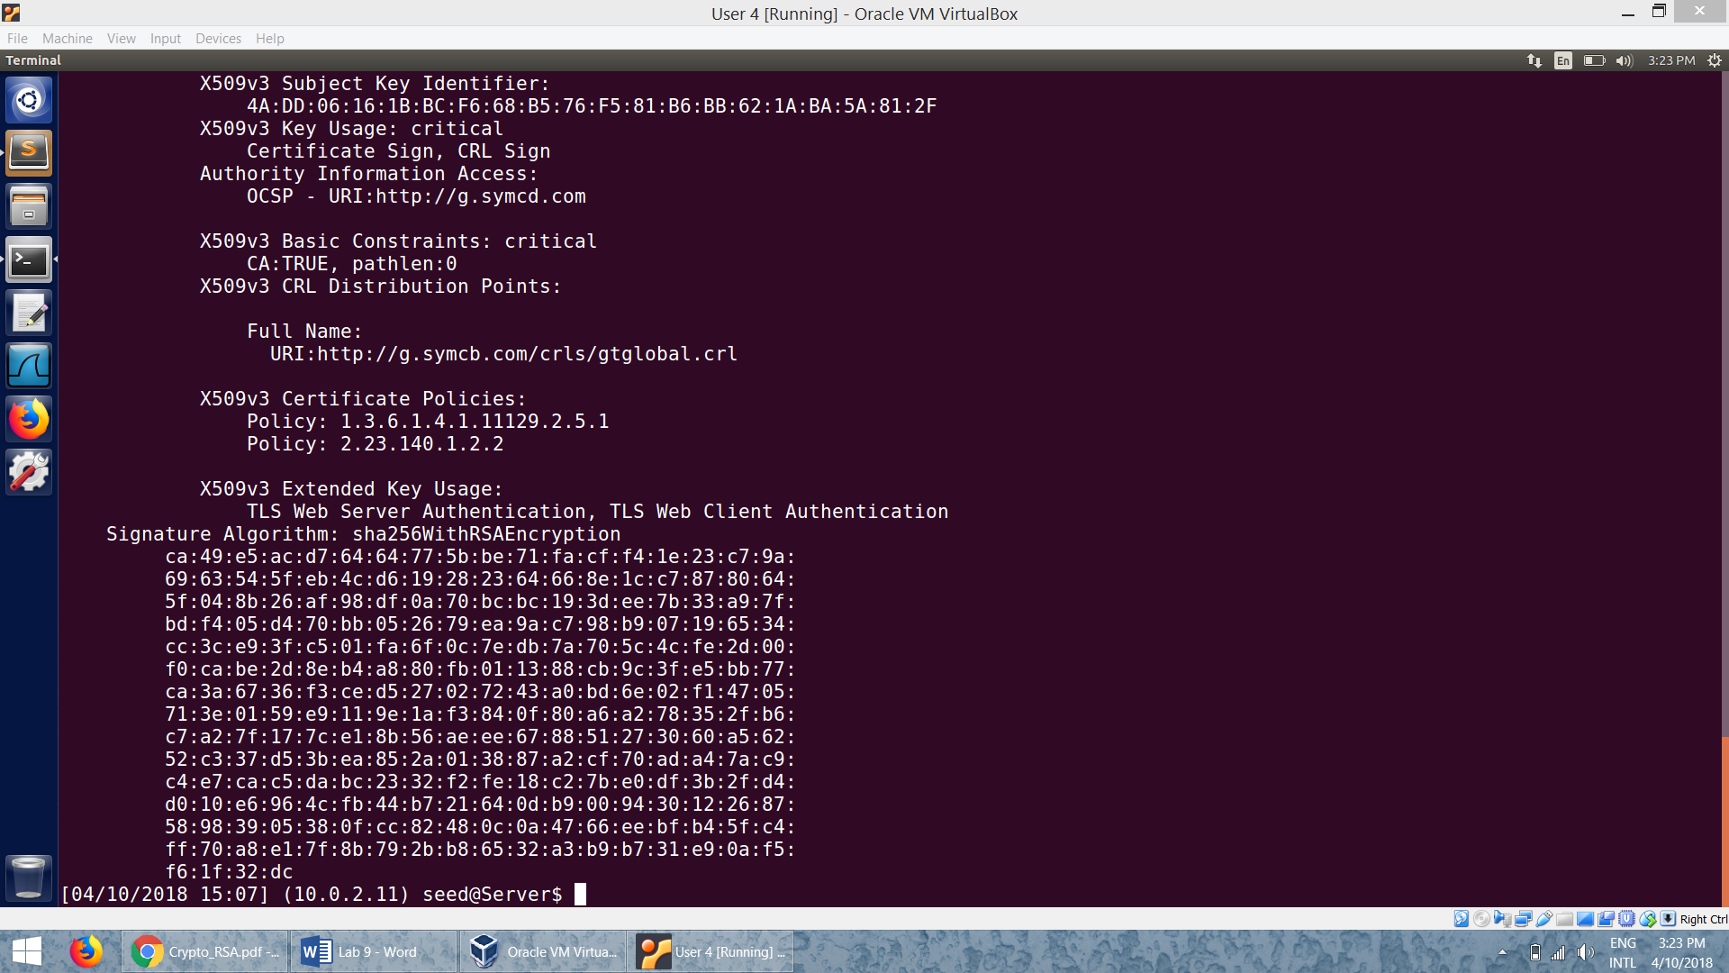

* We remove all the colons and spaces from the signature:

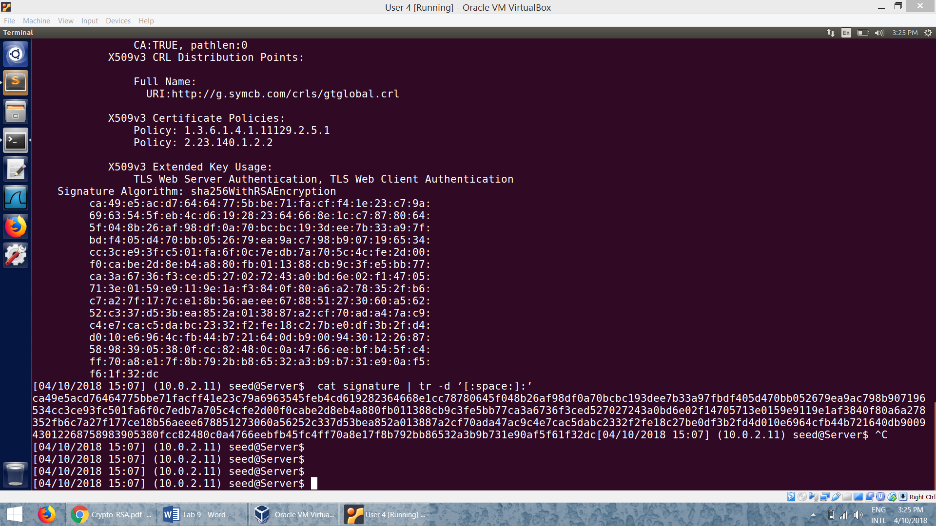

**Step 4: Extract the body of the server’s certificate**

* We use the following command to extract the body of the certificate:

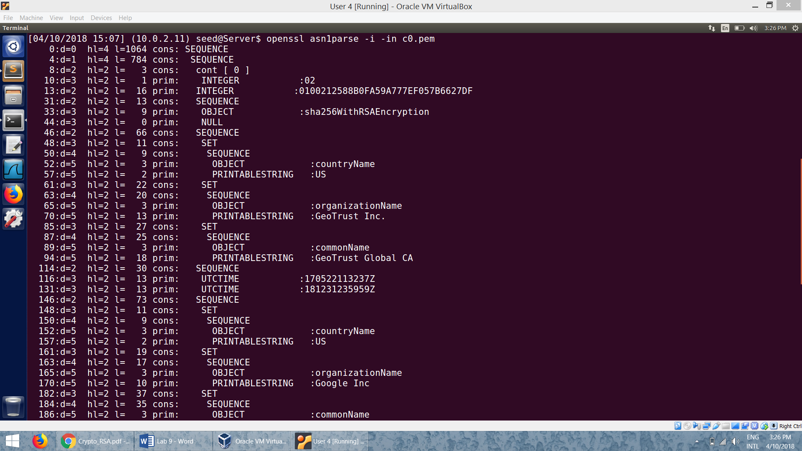

* In this we cannot determine the end of the body. So we use *-strparse* to get the field from the offset 4, which will give us the body of the certificate, excluding the signature block.

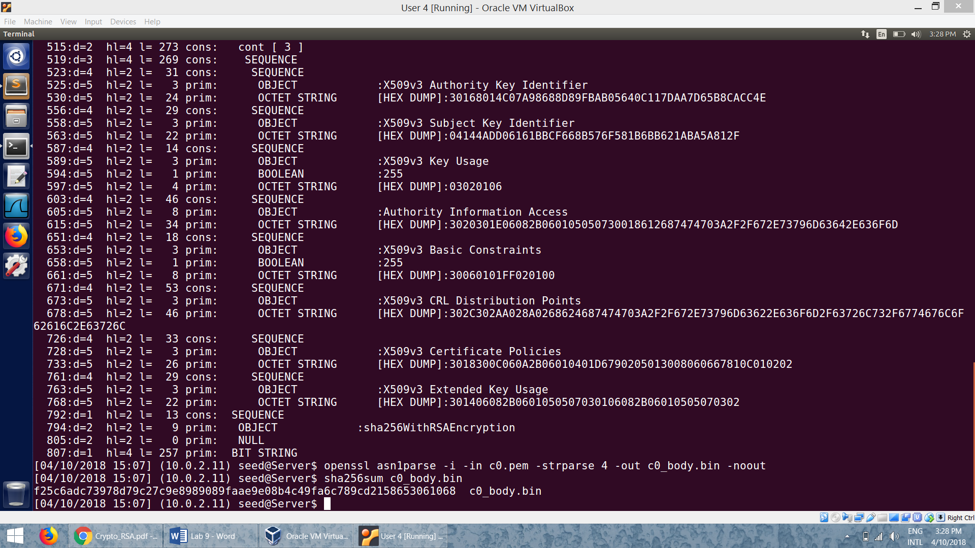

**Step 5: Verify the signature.**

* Code:

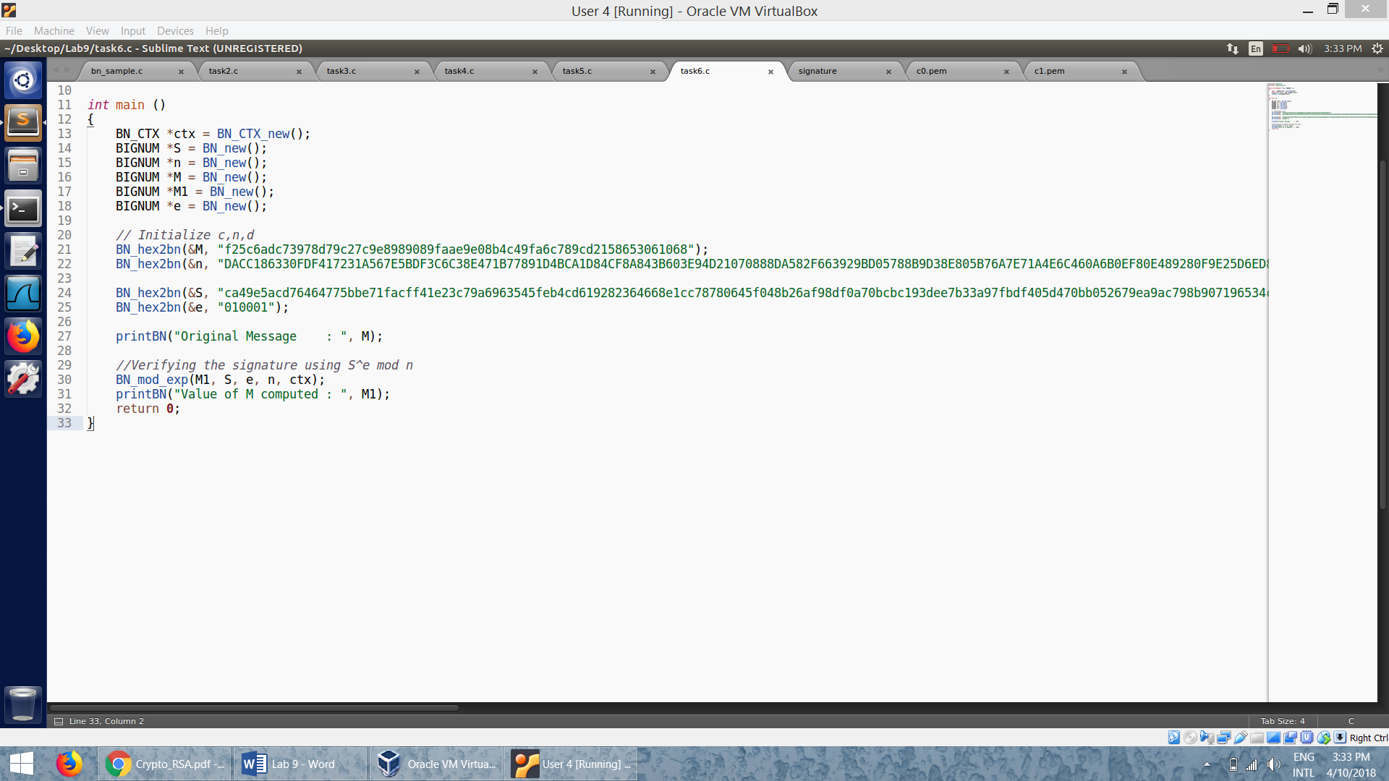

* We use the values obtained from the previous steps, get the signature and verify the signature obtained with the original signature.

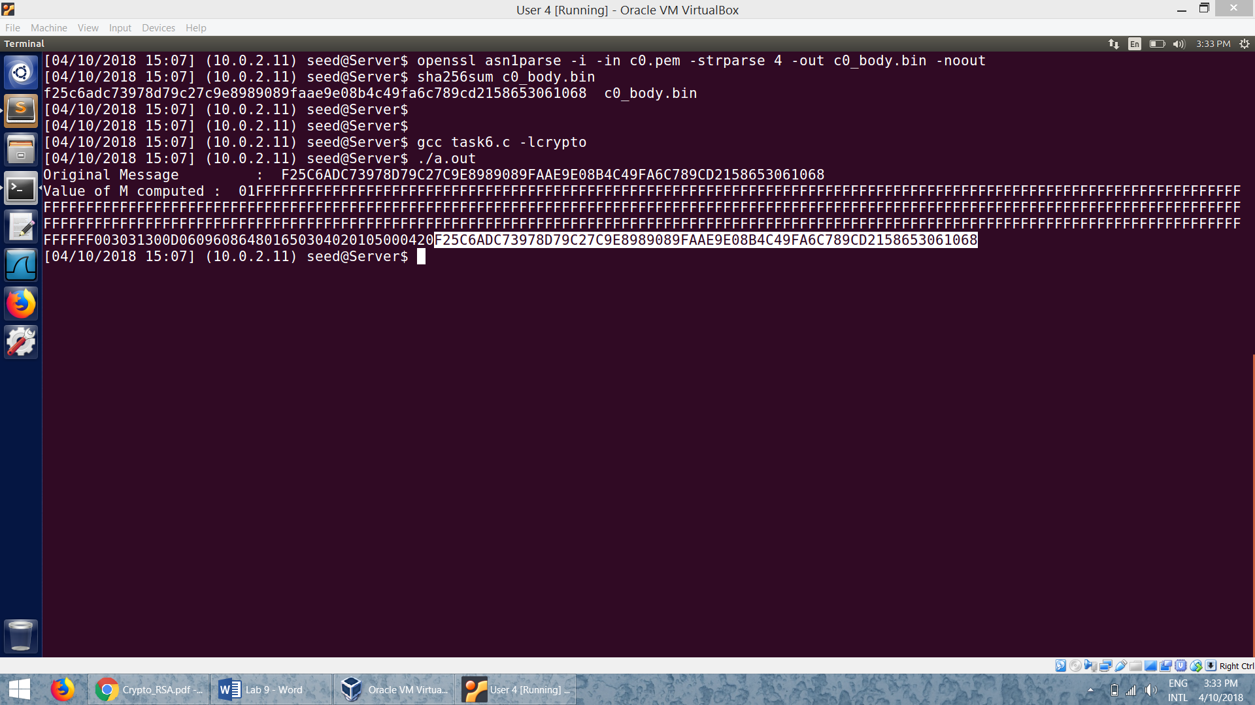

* We can notice that the original message and the hash value of the computed message is the same. Hence we can conclude that the *www.google.com* certificate is verified to be right.